PROGRAM – 1
AIM: Create a program that prompts the user for their name and age and prints a personalized message.
SOURCE CODE:
using System;
class PersonalizedMessage
{
static void Main()
{
Console.WriteLine("Name: Roshni"); Console.WriteLine("Roll No: 66"); Console.WriteLine("Class: IT-B\n");

Console.Write("Enter your name: "); string name = Console.ReadLine();

Console.Write("Enter your age: ");
int age = Convert.ToInt32(Console.ReadLine());

Console.WriteLine("Hello, " + name + "! You are " + age + " years old.");
}
}
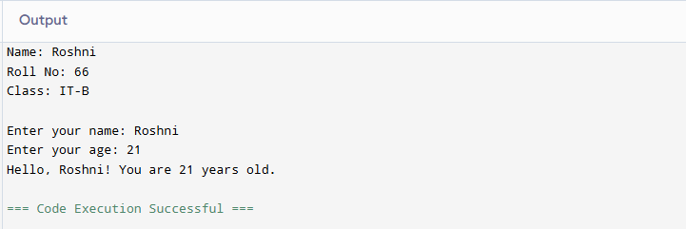

PROGRAM – 2
AIM: Create a program that prompts the user for their age and tells them if they can vote in the next election.
SOURCE CODE:
using System; class Program
{
static void Main()
{
Console.WriteLine("Name: Roshni"); Console.WriteLine("Class: IT-B"); Console.WriteLine("Roll No: 66"); Console.WriteLine(); Console.Write("Enter your age: ");
int age = Convert.ToInt32(Console.ReadLine()); if (age >= 18)
{
Console.WriteLine("You are eligible to vote in the next election.");
}
else
{
Console.WriteLine("You are not eligible to vote in the next election.");
}
}
}
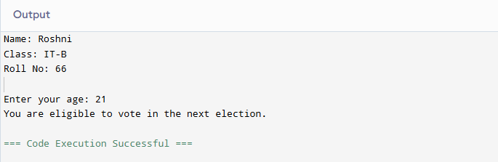

PROGRAM – 3
AIM: Create a program that calculates the factorial of a number entered by the user using a loop.
SOURCE CODE:
using System; class Program
{
static void Main()
{
Console.WriteLine("Name: Roshni"); Console.WriteLine("Class: IT-B"); Console.WriteLine("Roll No: 66");

Console.Write("Enter a number to find its factorial: "); int num = Convert.ToInt32(Console.ReadLine());

long factorial = 1;
for (int i = 1; i <= num; i++)
{
factorial *= i;
}
Console.WriteLine("Factorial of " + num + " is: " + factorial);
}
}
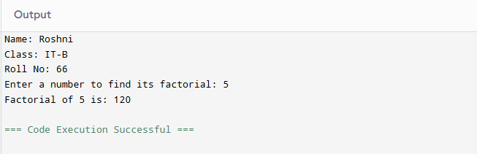

PROGRAM - 4
AIM: Create a program that prompts the user for a list of numbers and then sorts them in ascending order.
SOURCE CODE:
using System;
using System.Collections.Generic; class Program
{
static void Main()
{
Console.WriteLine("Name: Roshni"); Console.WriteLine("Class: IT-B"); Console.WriteLine("Roll No: 66\n");

Console.Write("Enter numbers separated by spaces: "); string input = Console.ReadLine();

string[] parts = input.Split(' ', StringSplitOptions.RemoveEmptyEntries); List<int> numbers = new List<int>();
foreach (string part in parts)
{
numbers.Add(Convert.ToInt32(part));
}
numbers.Sort();
Console.WriteLine("Numbers in ascending order:"); foreach (int num in numbers)
{
Console.Write(num + " ");
}
Console.WriteLine();
}
}

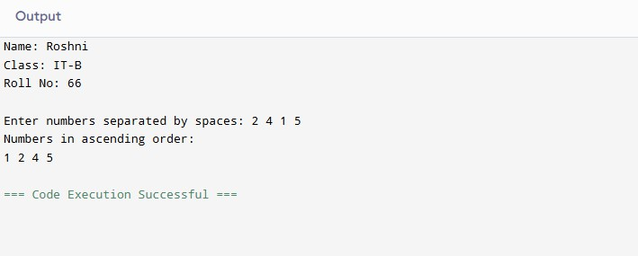

PROGRAM - 5
AIM: Create a program that prompts the user for a string and then prints out the string reversed.
SOURCE CODE:
using System;

class Program
{
static void Main()
{
Console.WriteLine("Name: Roshni"); Console.WriteLine("Class: IT-B"); Console.WriteLine("Roll No: 66\n");

Console.Write("Enter a string: "); string input = Console.ReadLine();

char[] charArray = input.ToCharArray(); Array.Reverse(charArray);
string reversed = new string(charArray);

Console.WriteLine("Reversed string: " + reversed);
}
}
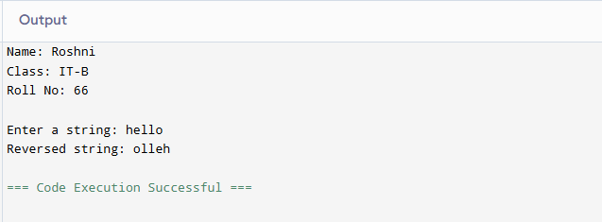

PROGRAM - 6
AIM: Create a program that defines a function to calculate the area of a circle based on the radius entered by the user.
SOURCE CODE:
using System; class Program
{
static double CalculateCircleArea(double radius)
{
return Math.PI * radius * radius;
}
static void Main()
{
Console.WriteLine("Name: Roshni"); Console.WriteLine("Class: IT-B"); Console.WriteLine("Roll No: 66\n");

Console.Write("Enter the radius of the circle: ");
double radius = Convert.ToDouble(Console.ReadLine()); double area = CalculateCircleArea(radius);

Console.WriteLine("Area of the circle: " + area);
}
}
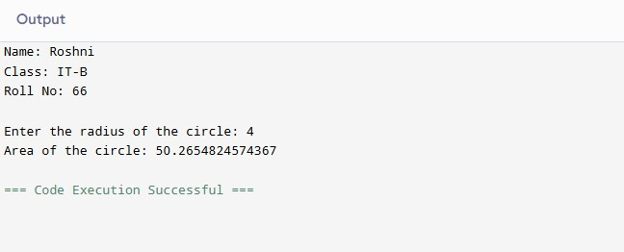

PROGRAM - 7
AIM: Create a program that defines a class to represent a car and then creates an object of that class with specific attributes.
SOURCE CODE:
using System; class Car
{
public string Brand; public string Model; public int Year;
public void DisplayDetails()
{
Console.WriteLine("Car Brand: " + Brand); Console.WriteLine("Car Model: " + Model); Console.WriteLine("Year of Manufacture: " + Year);
}
}
class Program
{
static void Main()
{
Console.WriteLine("Name: Roshni"); Console.WriteLine("Class: IT-B"); Console.WriteLine("Roll No: 66\n"); Car myCar = new Car(); myCar.Brand = "Toyota"; myCar.Model = "Corolla"; myCar.Year = 2022; myCar.DisplayDetails();
}
}

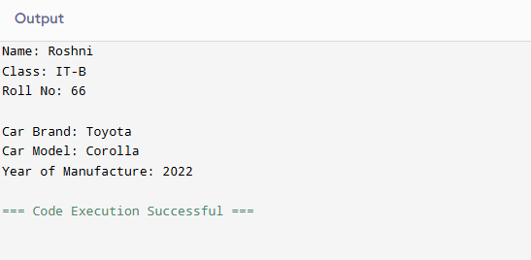

PROGRAM - 8
AIM: Create a program that reads data from a file and writes it to another file in a different format.
SOURCE CODE:
using System; using System.IO; class Program7
{
static void Main()
{
string inputFile = "input.txt"; string outputFile = "output.txt"; try
{
string[] lines = File.ReadAllLines(inputFile);

using (StreamWriter writer = new StreamWriter(outputFile))
{
foreach (string line in lines)
{
writer.WriteLine(line.ToUpper());
}
}

Console.WriteLine($"Data from {inputFile} has been written to {outputFile} in uppercase.");
}
catch (Exception e)
{
Console.WriteLine("Error: " + e.Message);
}
}
}

Input.txt
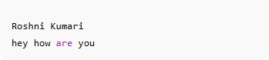
Output.txt
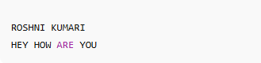

PROGRAM - 9
AIM: Create a program that prompts the user for two numbers and then divides them, handling any exceptions that may arise.
SOURCE CODE:
using System; class Program9
{
static void Main()
{
Console.WriteLine("Name: Roshni"); Console.WriteLine("Class: IT-B"); Console.WriteLine("Roll No: 66\n"); try
{
Console.Write("Enter num 1: ");
int num1 = Convert.ToInt32(Console.ReadLine()); Console.Write("Enter num 2: ");
int num2 = Convert.ToInt32(Console.ReadLine()); int result = num1 / num2; Console.WriteLine($"\nResult: {result}");
}
catch (DivideByZeroException)
{
Console.WriteLine("Error: Division by zero is not allowed.");
}
catch (FormatException)
{
Console.WriteLine("Error: Please enter valid numbers.");
}
catch (Exception e)
{
Console.WriteLine("Unexpected error: " + e.Message);

}
}
}
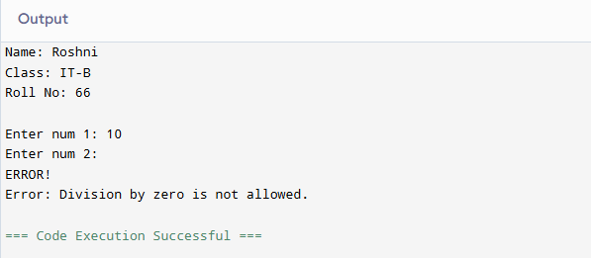

PROGRAM - 10
AIM: Create a program that uses a graphical user interface to allow the user to perform simple calculations.
SOURCE CODE:
using System;
using System.Windows.Forms; namespace CalculatorApp
{
public partial class Form1 : Form
{
TextBox input1, input2, resultBox; Button addBtn, subBtn, mulBtn, divBtn;

public Form1()
{
InitializeComponent();

this.Text = "Simple Calculator"; this.Width = 300;
this.Height = 250;

Label label1 = new Label() { Text = "Enter first number:", Top = 20, Left = 20 }; Label label2 = new Label() { Text = "Enter second number:", Top = 60, Left = 20 }; input1 = new TextBox() { Top = 20, Left = 150, Width = 100 };
input2 = new TextBox() { Top = 60, Left = 150, Width = 100 };
resultBox = new TextBox() { Top = 160, Left = 150, Width = 100, ReadOnly = true };

addBtn = new Button() { Text = "+", Top = 100, Left = 20, Width = 50 }; subBtn = new Button() { Text = "-", Top = 100, Left = 80, Width = 50 }; mulBtn = new Button() { Text = "×", Top = 100, Left = 140, Width = 50 }; divBtn = new Button() { Text = "÷", Top = 100, Left = 200, Width = 50 };

Label resultLabel = new Label() { Text = "Result:", Top = 160, Left = 20 };

addBtn.Click += (s, e) => Calculate("+"); subBtn.Click += (s, e) => Calculate("-"); mulBtn.Click += (s, e) => Calculate("*"); divBtn.Click += (s, e) => Calculate("/");

this.Controls.Add(label1); this.Controls.Add(label2); this.Controls.Add(input1); this.Controls.Add(input2); this.Controls.Add(resultBox); this.Controls.Add(addBtn); this.Controls.Add(subBtn); this.Controls.Add(mulBtn); this.Controls.Add(divBtn); this.Controls.Add(resultLabel);
}

void Calculate(string op)
{
try
{
double num1 = Convert.ToDouble(input1.Text); double num2 = Convert.ToDouble(input2.Text); double result = 0;

switch (op)
{
case "+": result = num1 + num2; break; case "-": result = num1 - num2; break; case "*": result = num1 * num2; break; case "/": result = num1 / num2; break;
}

resultBox.Text = result.ToString();
}
catch (Exception)
{
MessageBox.Show("Please enter valid numbers.");
}
}
}
}
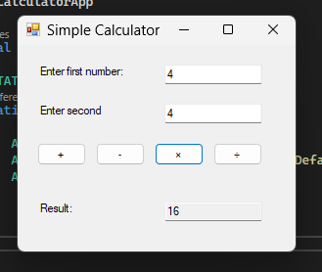

PROGRAM - 11
AIM: Create a program that uses multithreading to perform a time-consuming task in the background while the user can continue using the application.
SOURCE CODE:
using System;
using System.Threading; class Program
{
static void TimeConsumingTask()
{
for (int i = 1; i <= 5; i++)
{
Console.WriteLine($"Background task running... Step {i}"); Thread.Sleep(2000);
}
Console.WriteLine("Background task completed!");
}
static void Main()
{
Console.WriteLine("Name: Roshni"); Console.WriteLine("Class: IT-B"); Console.WriteLine("Roll No: 66\n");

Thread backgroundThread = new Thread(TimeConsumingTask); backgroundThread.Start();

Console.WriteLine("You can continue using the app while the task runs in background!"); Console.WriteLine("Type something below (the app remains responsive):");

string input = Console.ReadLine(); Console.WriteLine($"You typed: {input}");

backgroundThread.Join(); Console.WriteLine("Main thread finished.");
}
}
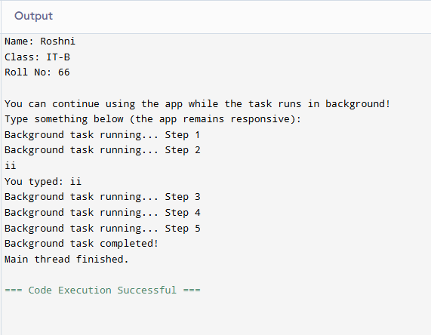

PROGRAM - 12
AIM: Create a program that uses LINQ to query and manipulate data from a database.
SOURCE CODE:
using System;
using System.Collections.Generic; using System.Linq;

class Program
{
class Student
{
public int ID { get; set; } public string Name { get; set; } public int Marks { get; set; }
}
static void Main()
{
Console.WriteLine("Name: Roshni"); Console.WriteLine("Class: IT-B"); Console.WriteLine("Roll No: 66\n");

List<Student> students = new List<Student>()
{
new Student { ID = 1, Name = "Aarav", Marks = 85 }, new Student { ID = 2, Name = "Riya", Marks = 72 }, new Student { ID = 3, Name = "Neha", Marks = 90 }, new Student { ID = 4, Name = "Karan", Marks = 60 }, new Student { ID = 5, Name = "Isha", Marks = 78 }
};
var highScorers = from s in students
where s.Marks > 75

orderby s.Marks descending select s;

Console.WriteLine("Students scoring above 75:\n"); foreach (var s in highScorers)
{
Console.WriteLine($"{s.Name} - Marks: {s.Marks}");
}

students = students.Select(s => { s.Marks += 5; return s; }).ToList();

Console.WriteLine("\nAfter adding 5 bonus marks:\n"); foreach (var s in students)
{
Console.WriteLine($"{s.Name} - New Marks: {s.Marks}");
}
}
}
